Ubuntu Linux Change Hostname (computer name)

**Display the current Ubuntu hostname**

Simply type the following command:  
$ hostname  
Sample outputs:  
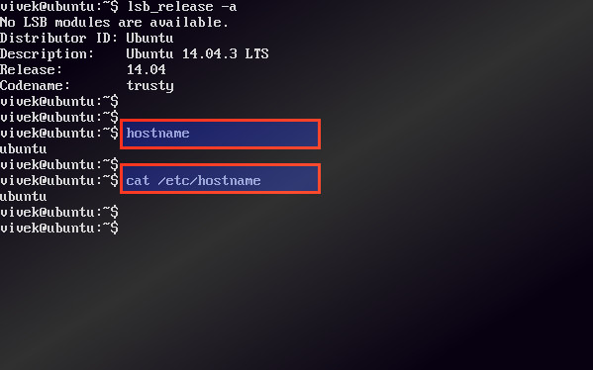Fig.01: Ubuntu Linux Show the hostname/computer name command

**Ubuntu change hostname command**

The procedure to change the computer name on Ubuntu Linux:

1. Type the following command to edit /etc/hostname using nano or vi text editor:  
   **sudo nano /etc/hostname**  
   Delete the old name and setup new name.
2. Next Edit the /etc/hosts file:  
   **sudo nano /etc/hosts**  
   Replace any occurrence of the existing computer name with your new one.
3. Reboot the system to changes take effect:  
   **sudo reboot**

Sample outputs:  
Gif 01: Ubuntu change the computer name demo

**How to change the Ubuntu server hostname without a system restart?**

Type the following commands:  
$ sudo hostname new-server-name-here  
Next edit the /etc/hostname file and update hostname:  
$ sudo nano /etc/hostname  
Finally, edit the /etc/hosts file and update the lines that reads your old-host-name:  
$ sudo nano /etc/hosts  
From:  
127.0.1.1 old-host-name  
To:  
127.0.1.1 new-server-name-here  
Save and close the file.

**Change Date**

Use [date -s](http://linux.die.net/man/1/date):

date -s '2014-12-25 12:34:56'

Run that as root or under sudo. Changing only one of the year/month/day is more of a challenge and will involve repeating bits of the current date. There are also GUI date tools built in to the major desktop environments, usually accessed through the clock.

To change only part of the time, you can use command substitution in the date string:

date -s "2014-12-25 $(date +%H:%M:%S)"